**Git & GitHub Project**

**Instructions**

1. Create a folder his name learn_git because all the work in this folder.

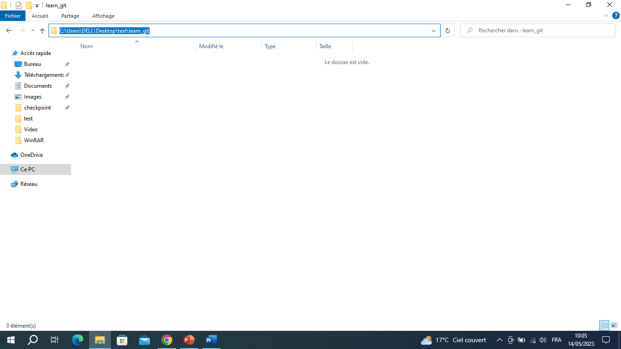

1. Command **cd** : make Git Bash in the correct url wich is C:\Users\DELL\Desktop\test_git

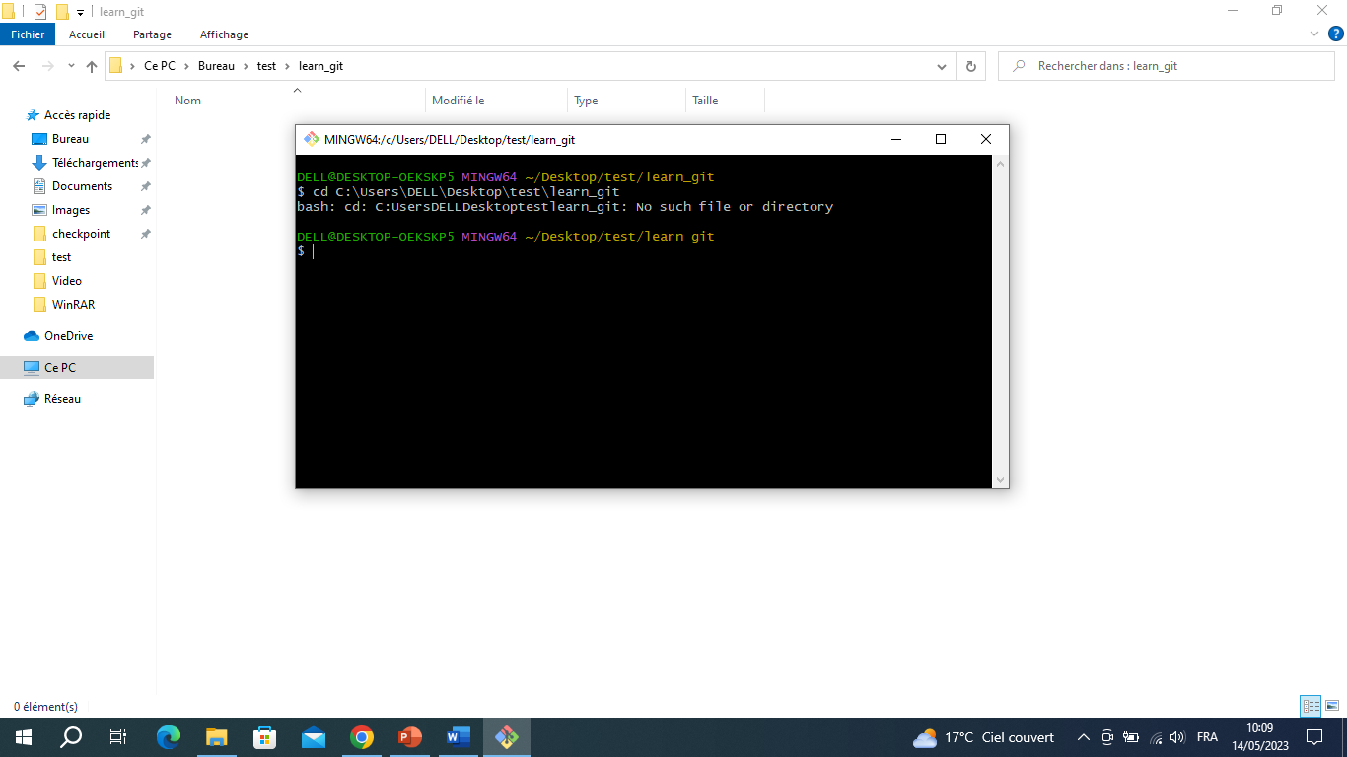

1. Command touch > : create a folder third.txt.

🡺 third.txt still not in stagen area (not tracked).

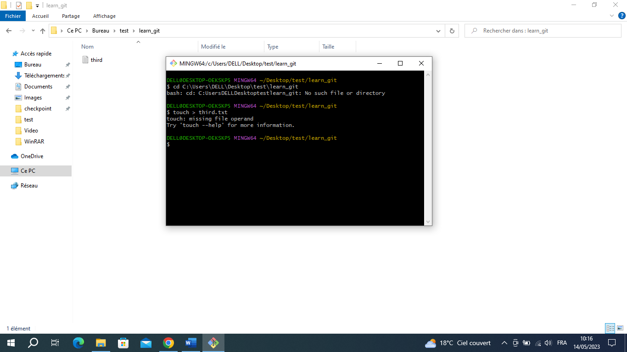

1. Command git init : initialize empty folder .git that will relate git with githob.

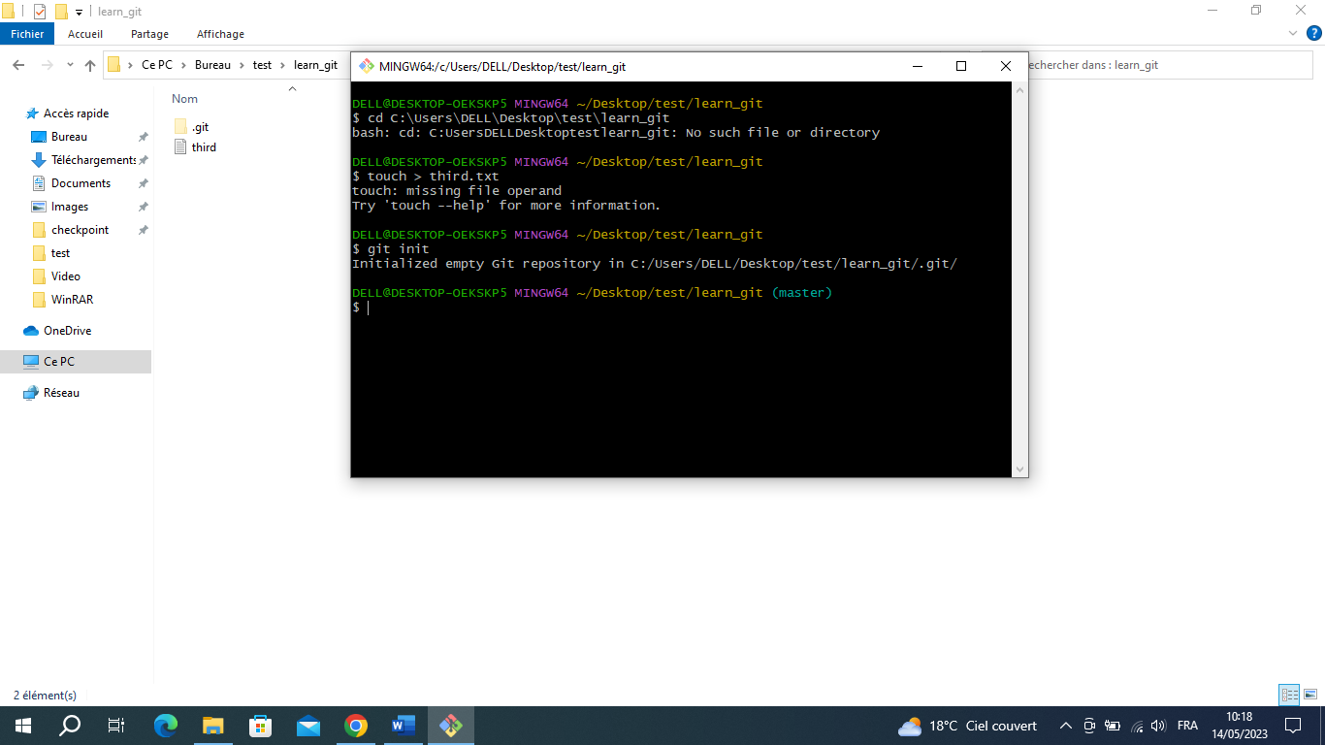

1. Command add : third.txt will be added to the staging area (wait for saving in local data base).

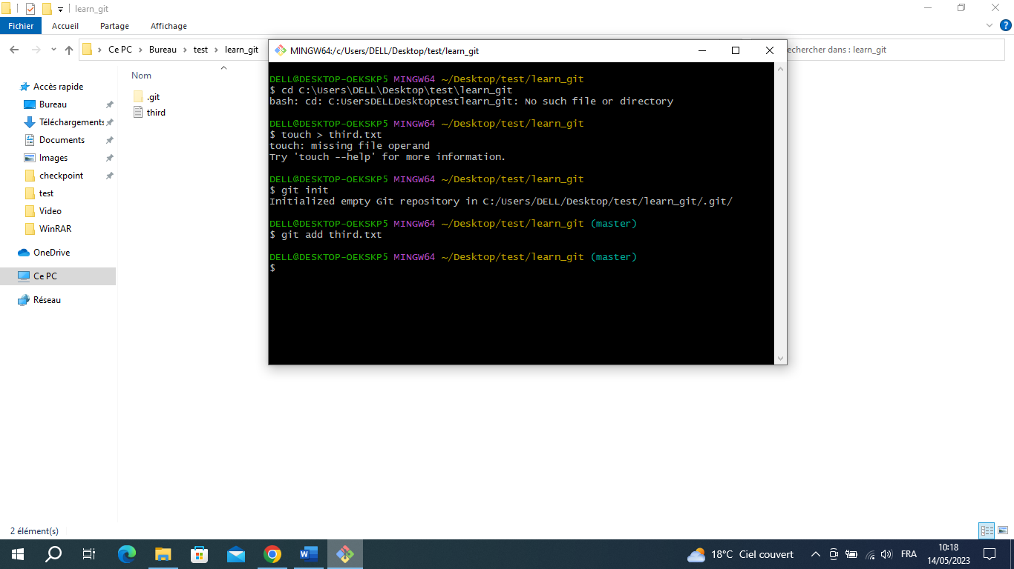

1. Command git commit -m : Add third.txt to the local data base.

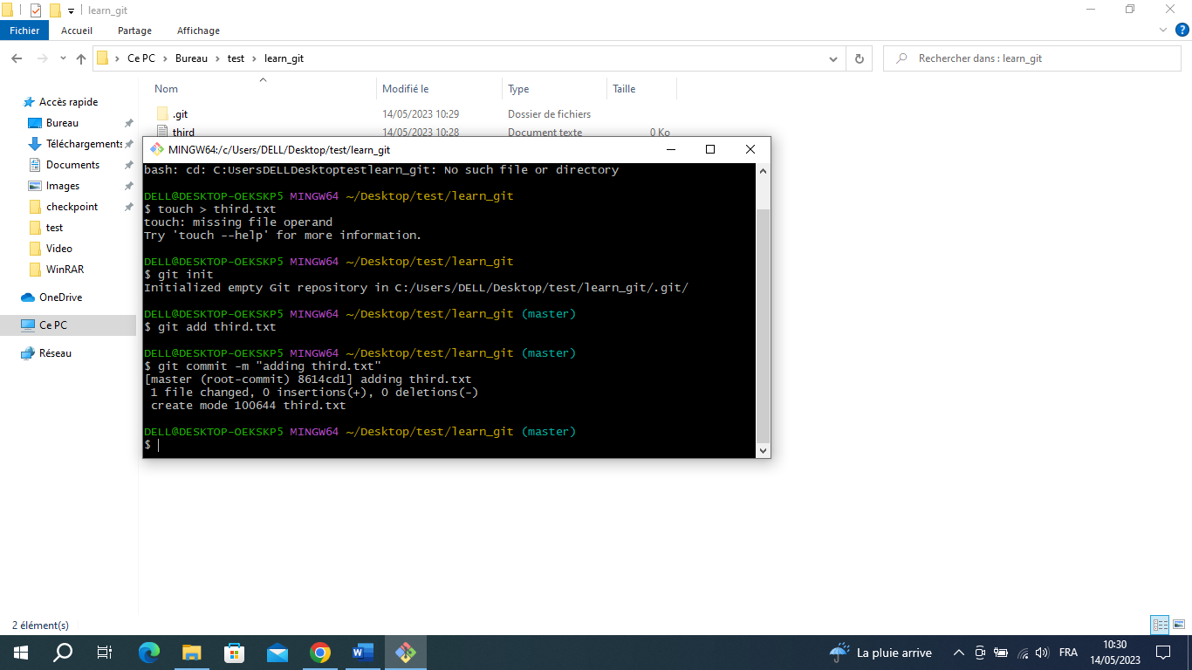

1. Command Git log : display all the history of command commit.

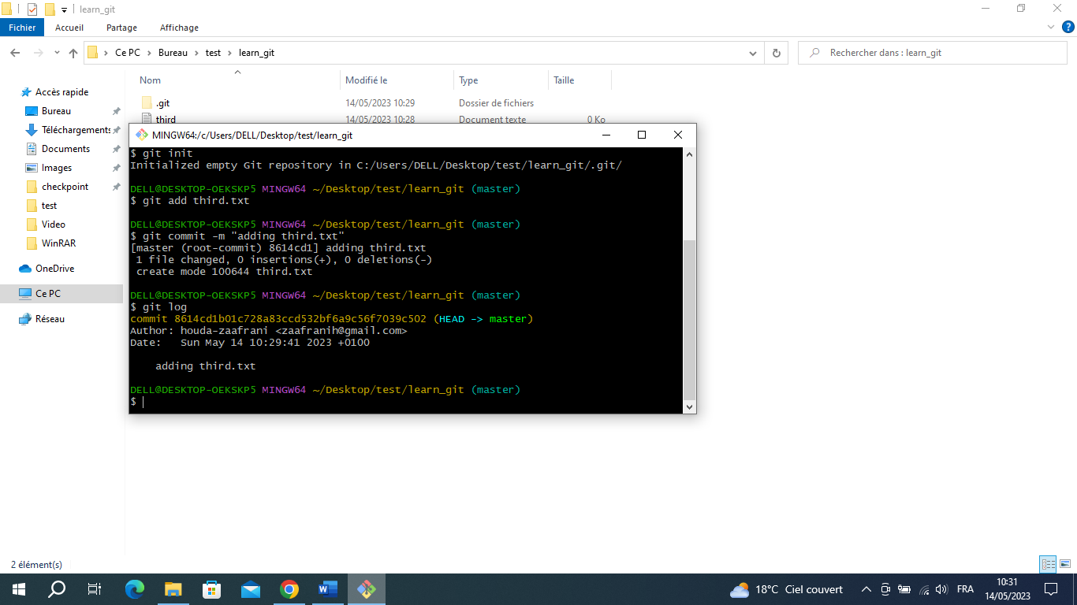

1. Command git add : Create file fourth.txt non tracked.

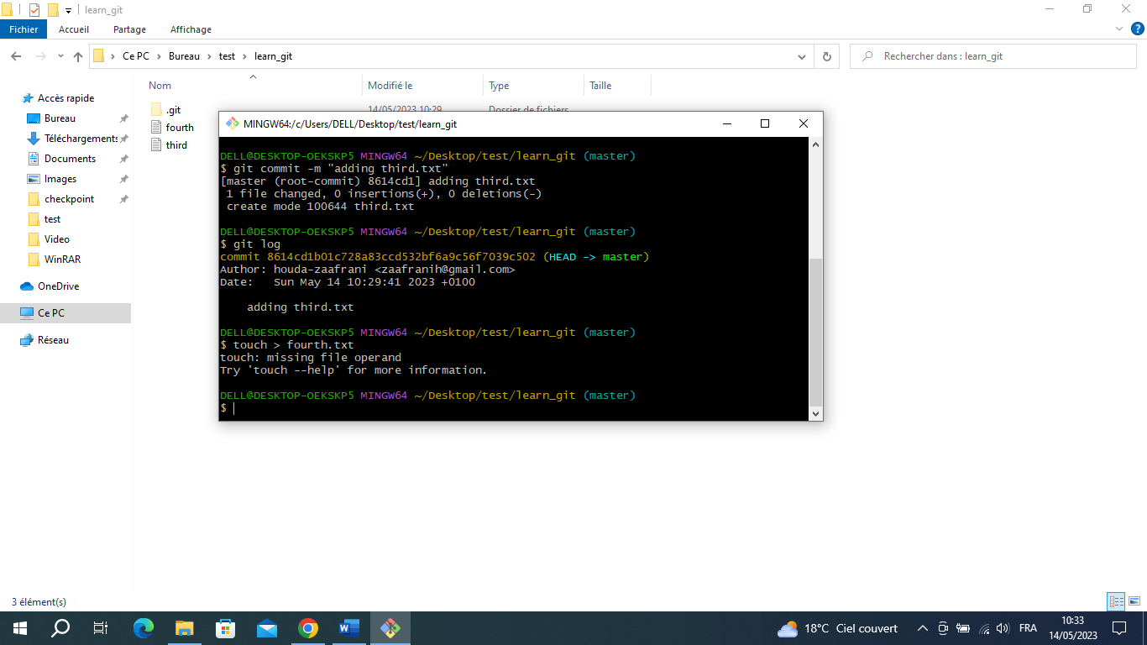

1. Command Add : add fourth.txt to staging area

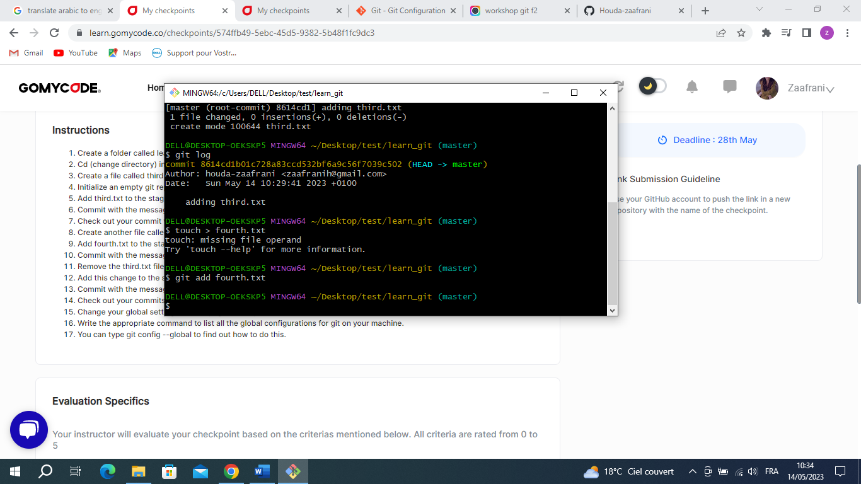

1. Command commit -m : add fourth.txt to the local data base.

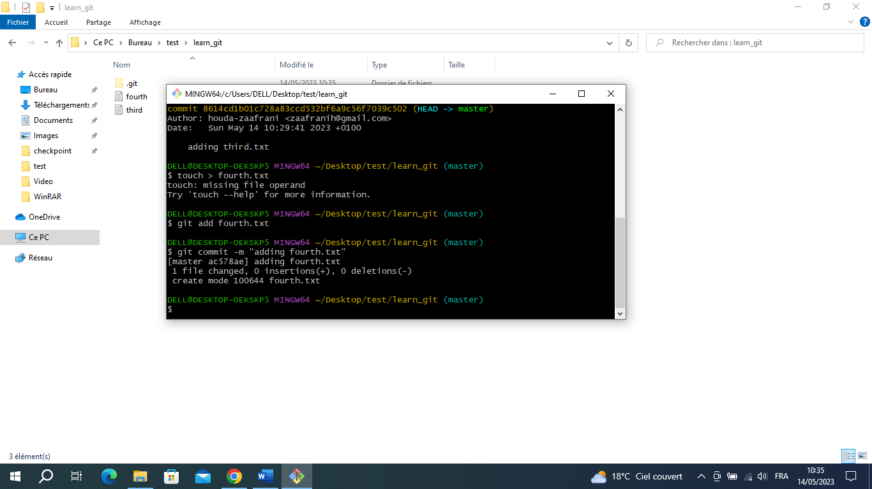

1. Command rm : Delate third.txt from get reprostory.

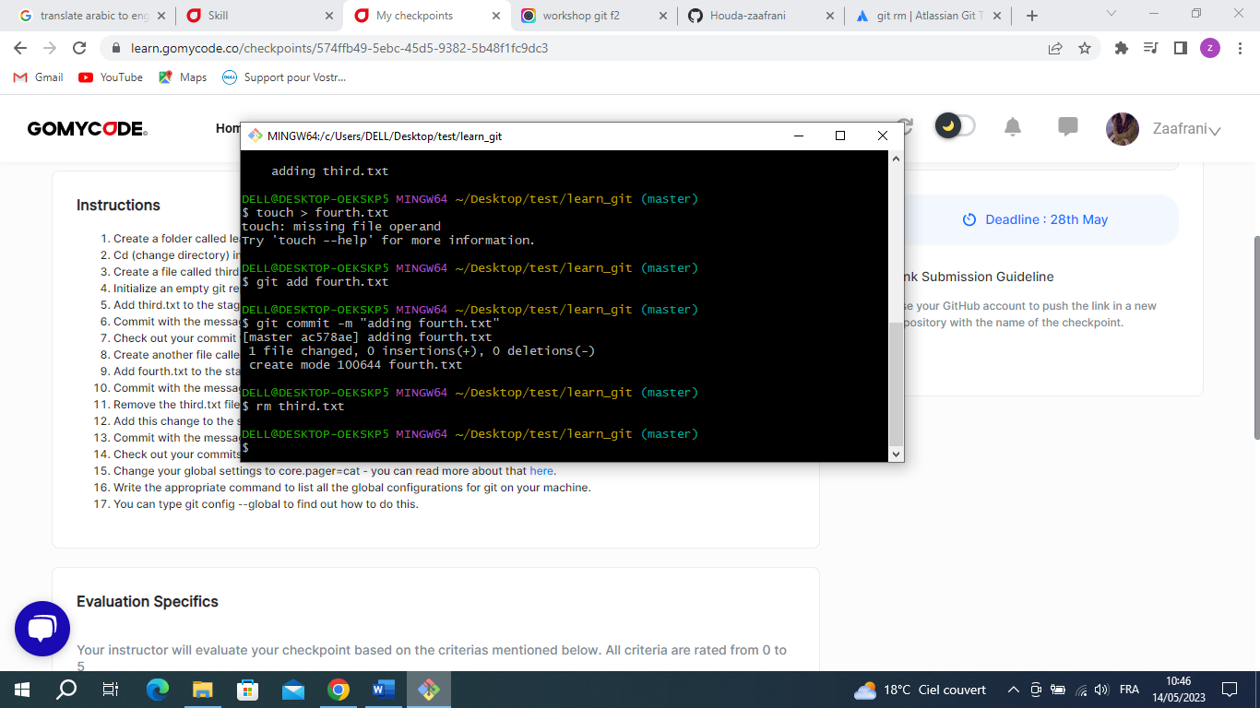

🡪if we write git status (make us see what we have)we will see ‘deleted third.txt’ in red.

🡪 third.txt not delated in staging area.

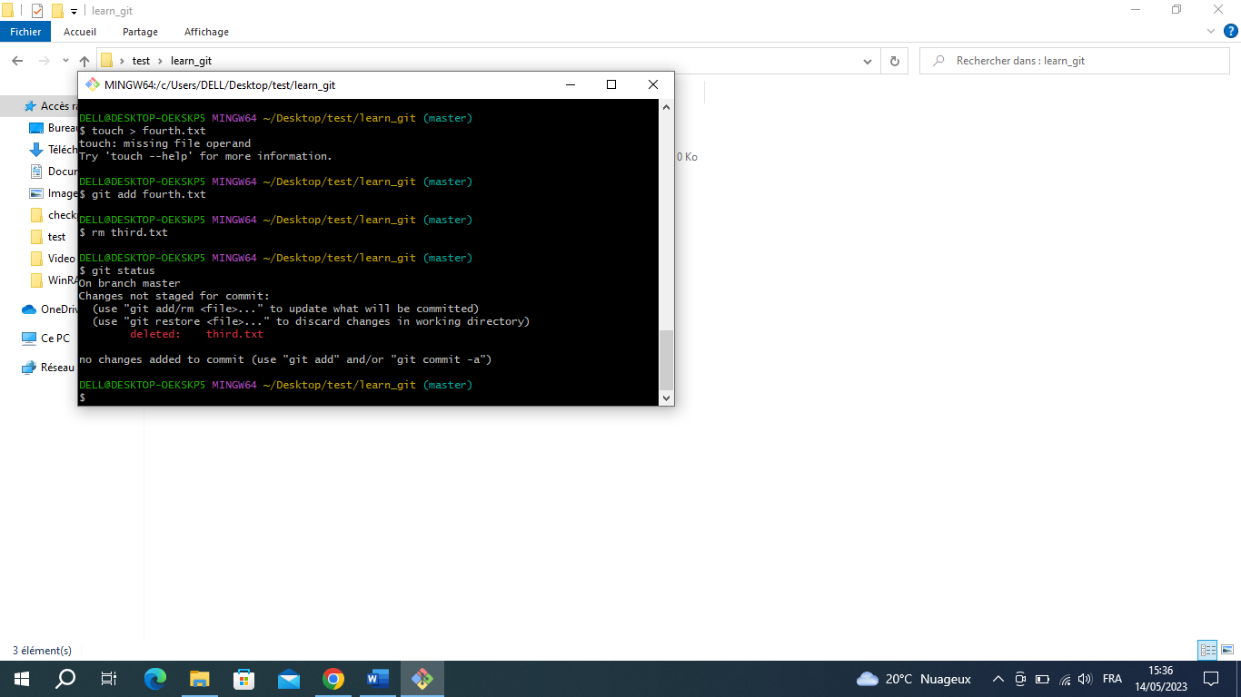

1. Command git . : add all changing (delate third.txt from staging area)

**🡪** we will see ‘deleted third.txt’ on green.

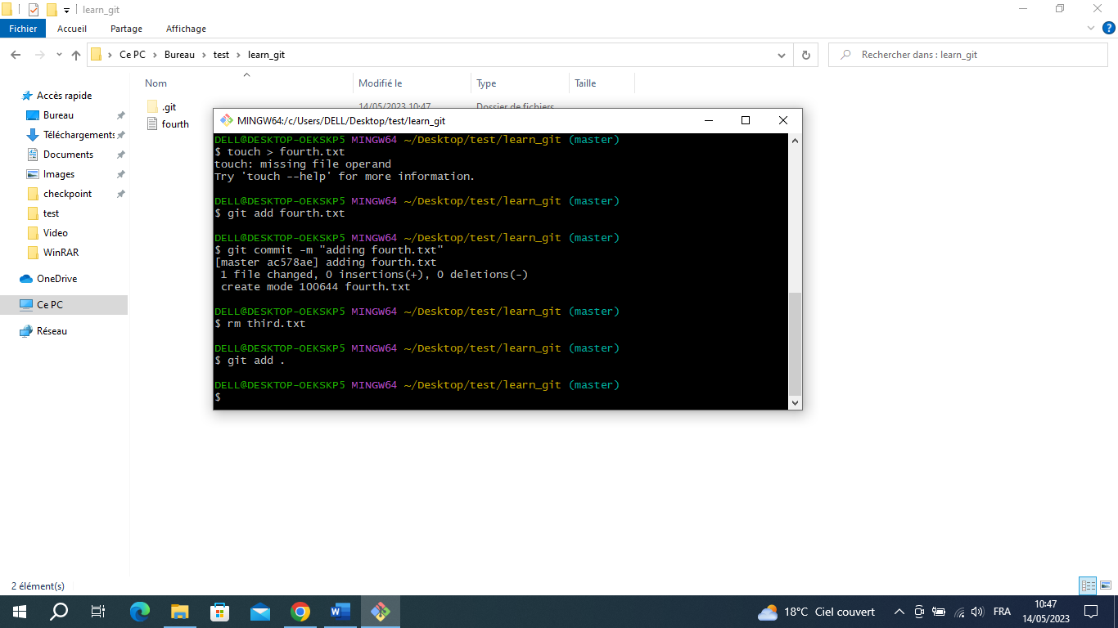

1. Command commit -m : Commit the message ‘removing third.txt’ to see this modification in the

history.

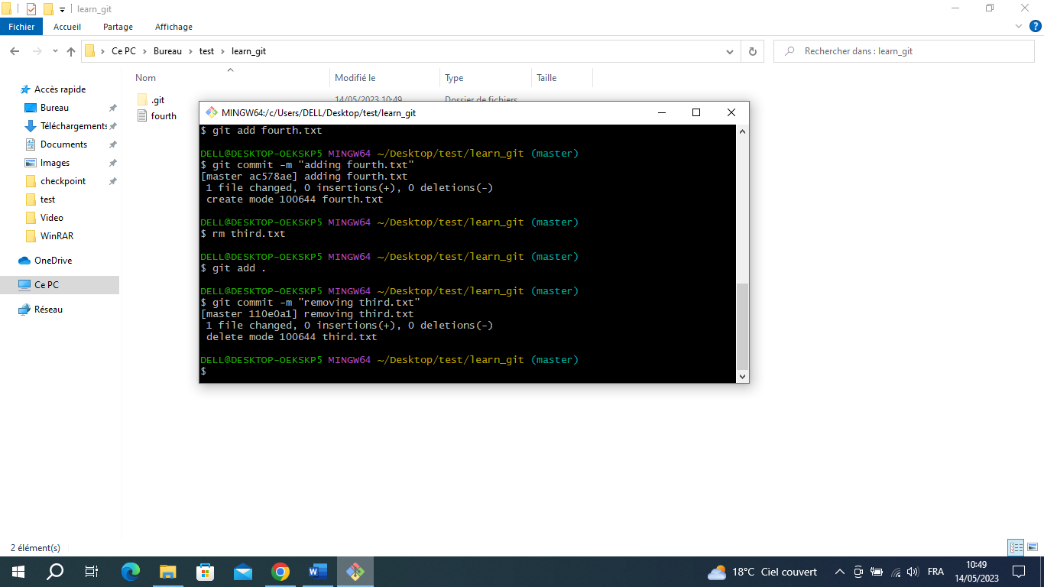

1. Command git log : See all history that we made it.

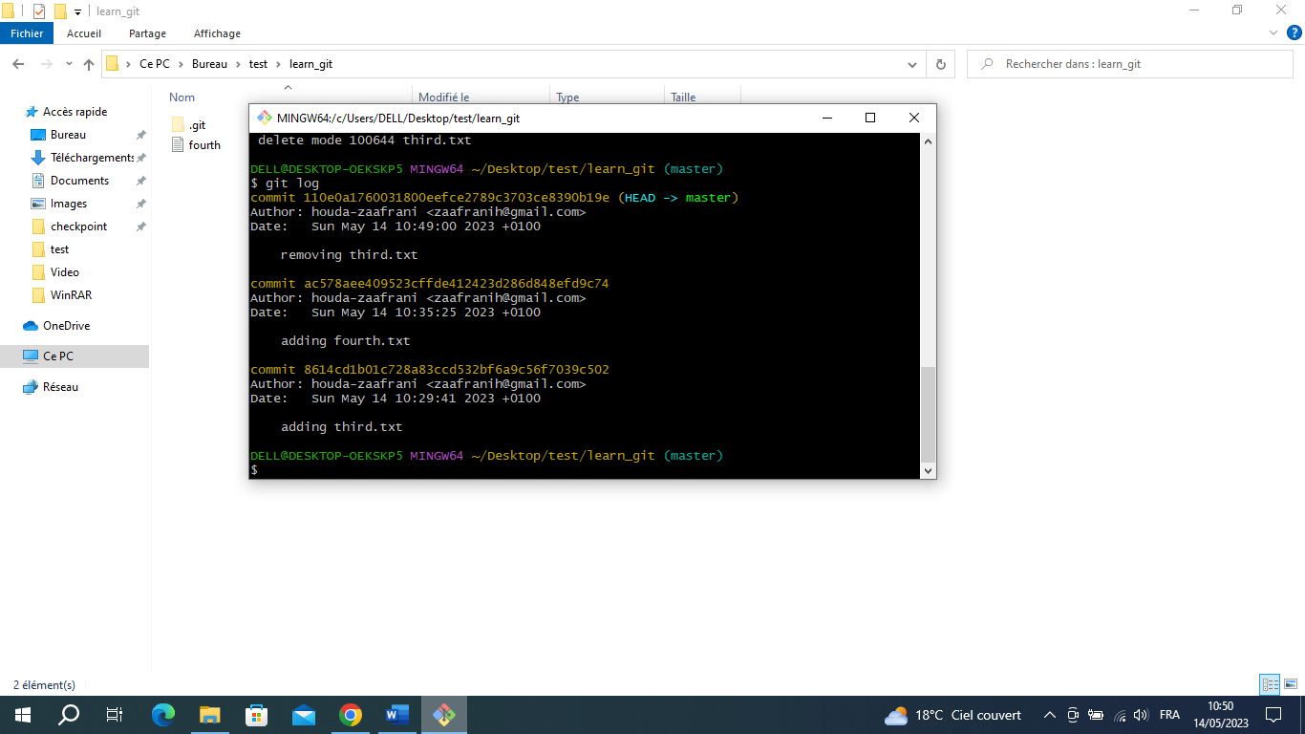

1. To modifie core.pager firstable we should whrite command git.config --global --list to see what

we save and after we can modifie.

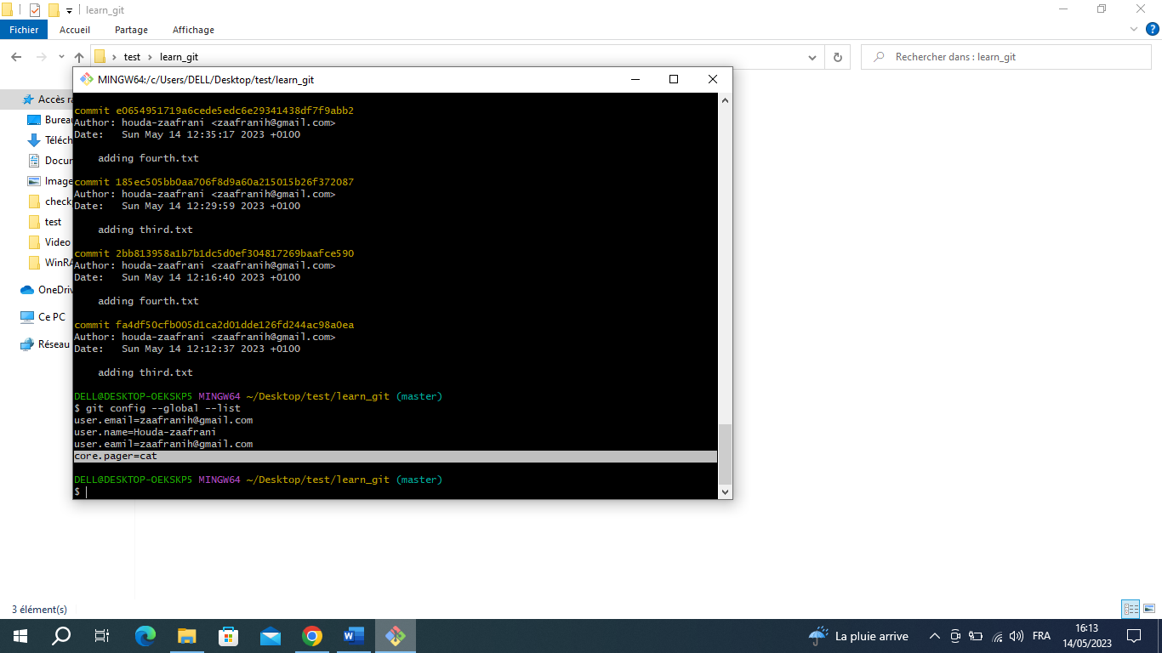

**🡪** command git.config –global care cat : modifie care with cat.

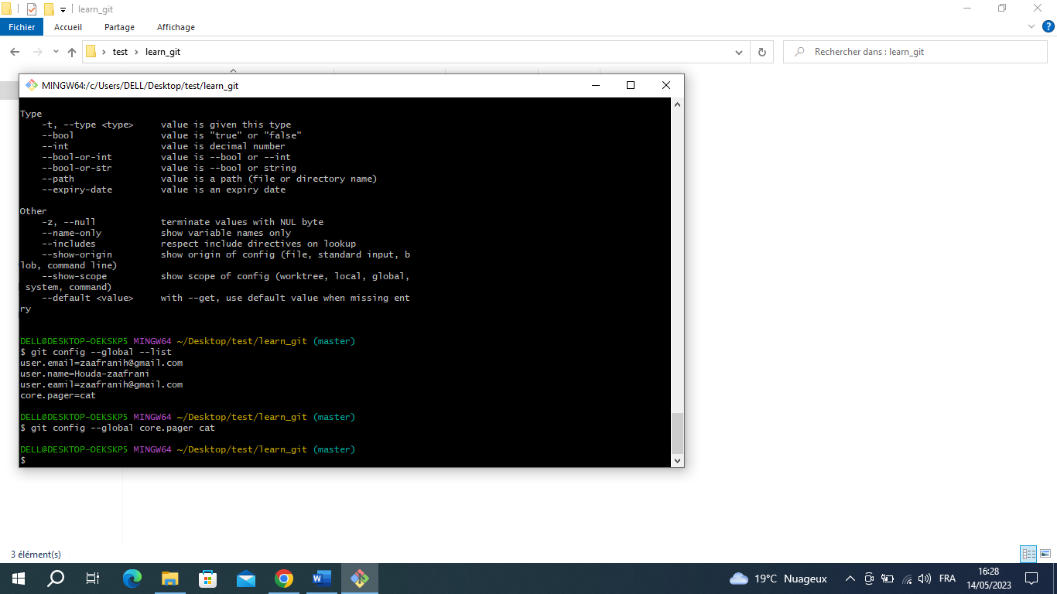

1. Command git config --global user.name et git config -- global user.email  : we will say to github

that we are the same person (name and email) who done the commands.

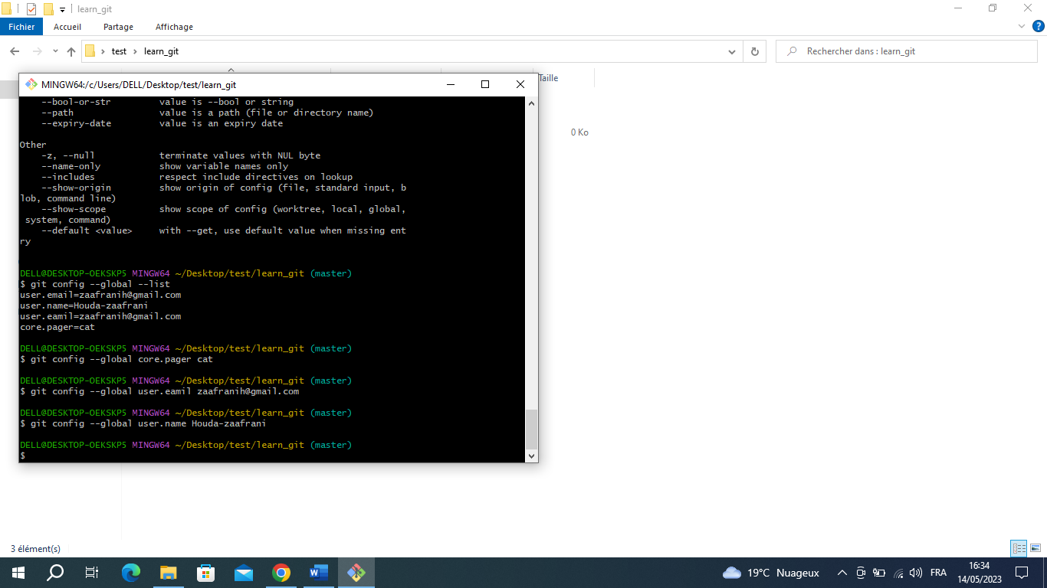

🡪command git config --global --liste : we will see all user wich is me with my name and email

